ASSIGNMENT-11.4
NAME :-P.CHARANKUMAR
ROLL NO :-2303A52138
BATCH -41
Task 1: Stack Implementation for Undo Operations (LIFO)
Scenario
You are building a text editor where users can undo their recent actions
(typing, deleting, formatting). Each action must be reversed in Last-In-First-
Out (LIFO) order.
Prompt Used:
# Build a Stack class for undo operations in a text editor.
# Include push, pop, peek, is_empty with docstrings.
# Add test cases and an alternative deque-based implementation.
AI-Generated Code
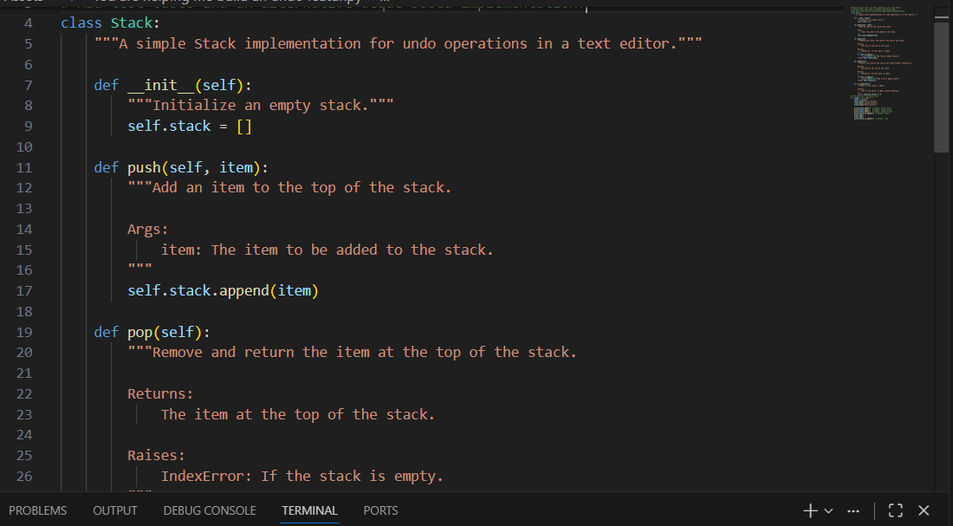
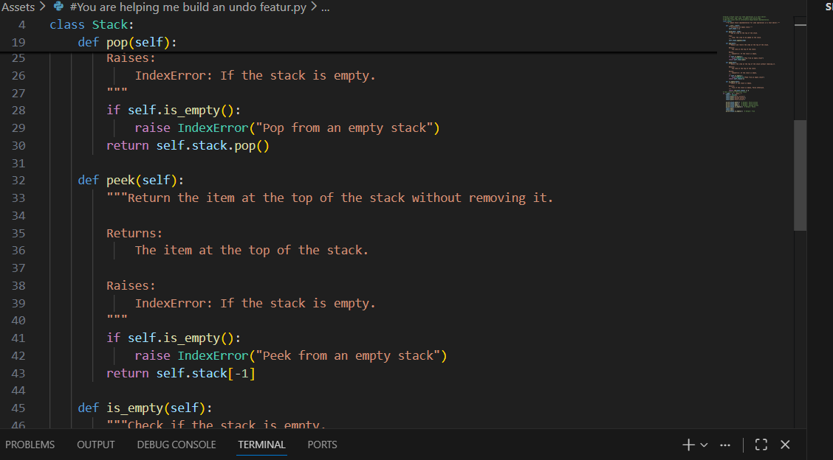
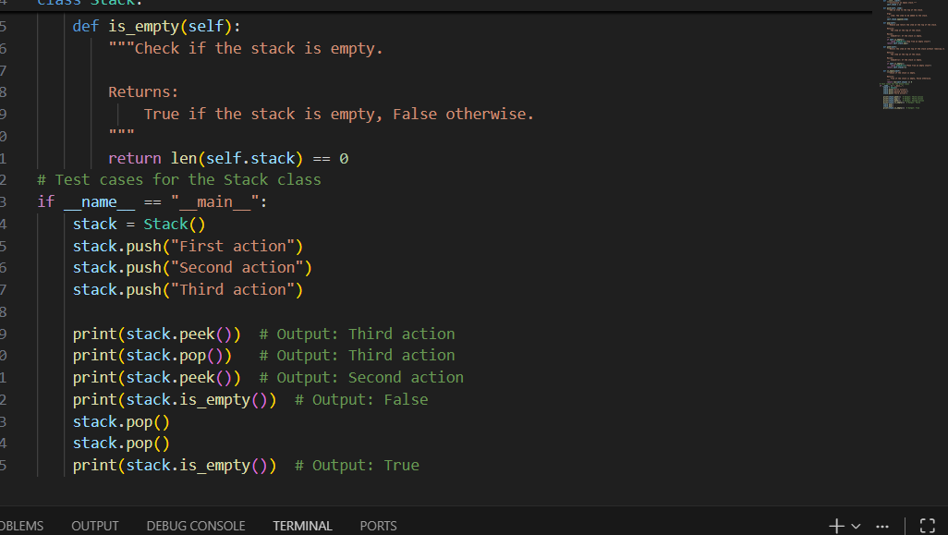
Output:-
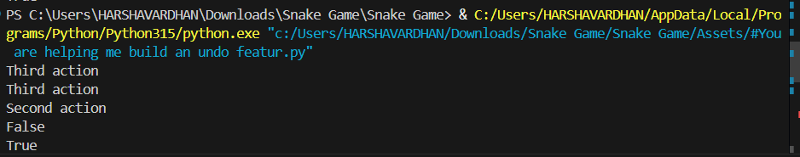
Explanation:
The code defines a `Stack` class that implements a simple stack data structure, which is commonly used for undo operations in text editors. The stack supports four main operations: `push`, `pop`, `peek`, and `is_empty`.
Task 2: Queue for Customer Service Requests (FIFO)
Scenario
You are developing a customer support system where service requests must be handled in the order they arrive.
Prompt Used:
# Implement a FIFO queue for customer service requests.
# First use a list-based approach, then an optimized deque-based approach.
# Include enqueue, dequeue, is_empty, test cases, and performance comparison.
# List-based approach
AI-Generated Code
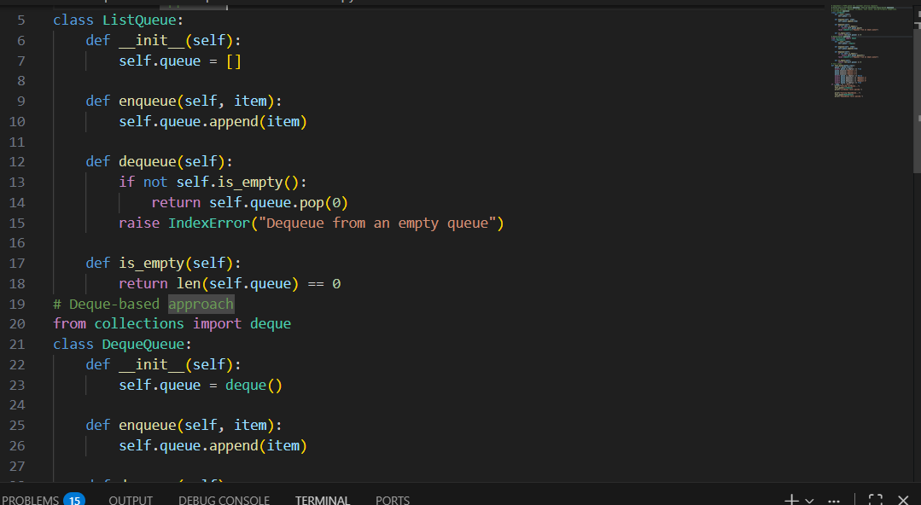
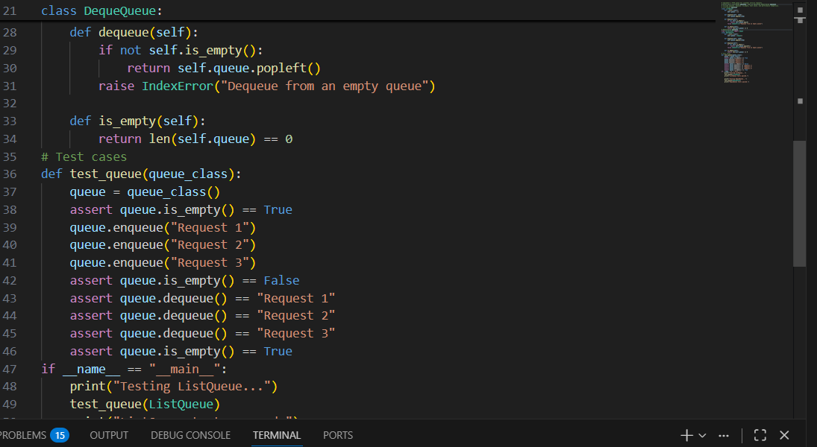
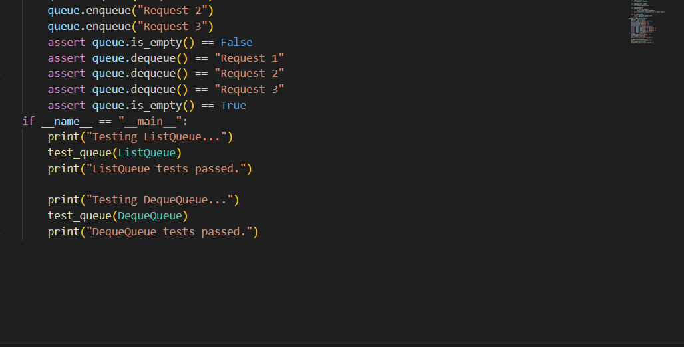
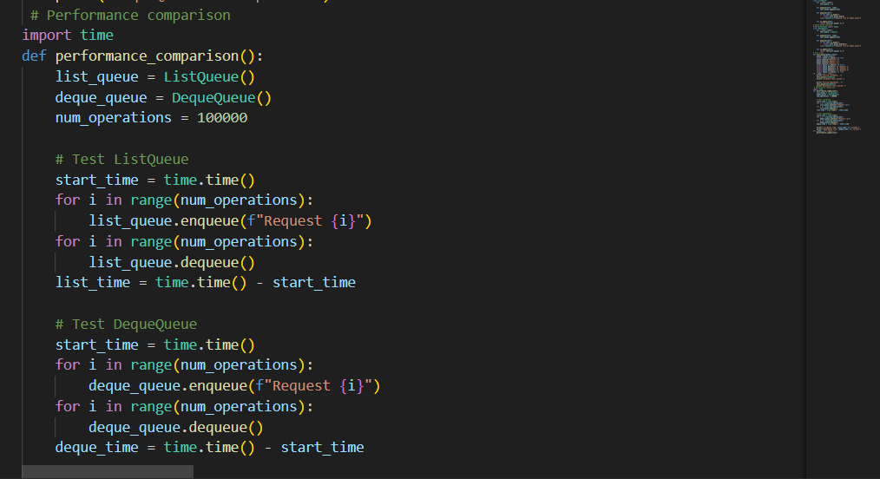
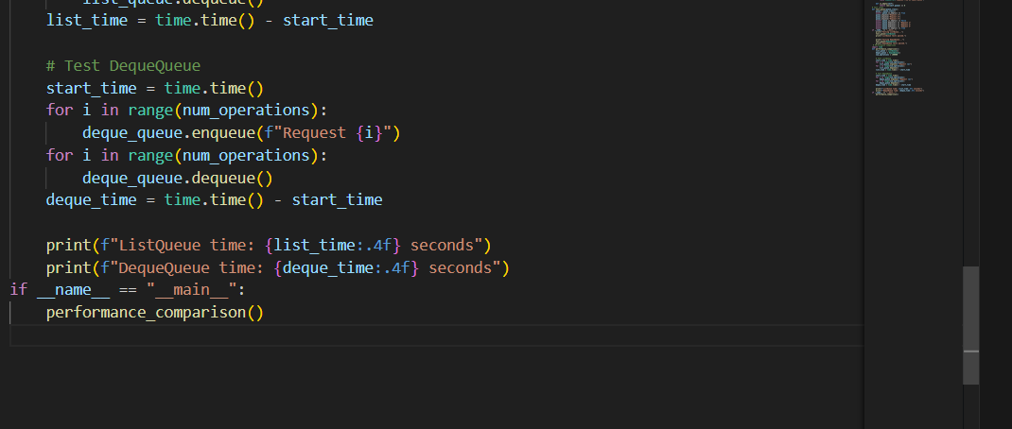
Output:-
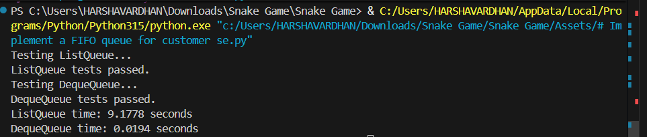
Explanation:
he code implements two versions of a FIFO (First-In-First-Out) queue for customer service requests: one using a list and the other using a deque from the collections module.
Task 3: Singly Linked List for Dynamic Playlist Management
Scenario
You are designing a music playlist feature where songs can be added or
removed dynamically while maintaining order.
Prompt Used:
# Implement a singly linked list for a music playlist.
# Support insert at end, delete by value, and traversal.
# Add comments explaining pointer manipulation and edge cases.
AI-Generated Code
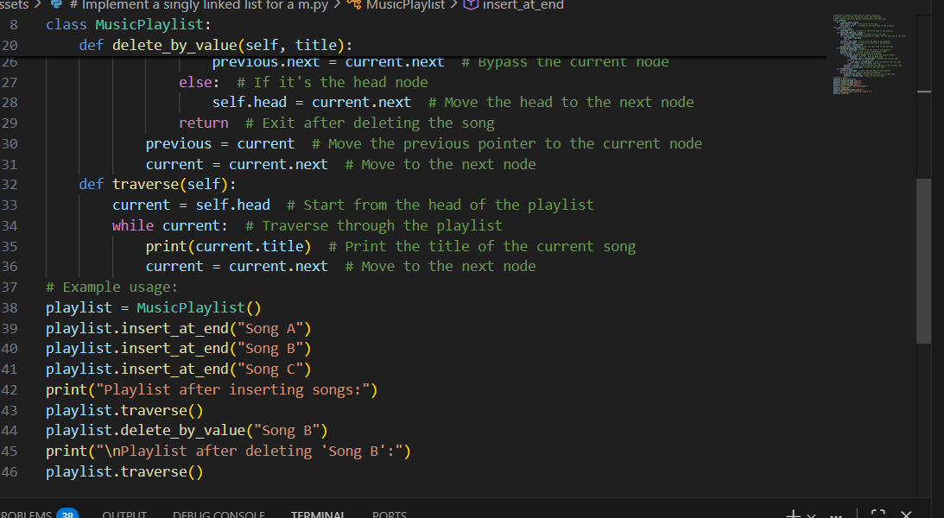
Output:-
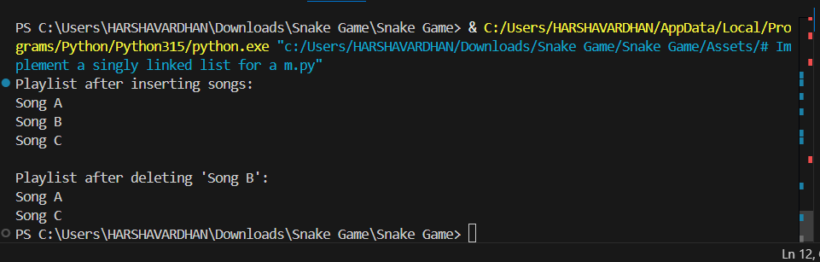
Explaination:
The code defines a singly linked list to represent a music playlist. Each song is represented as a node (SongNode) that contains the song title and a pointer to the next song. The MusicPlaylist class provides methods to insert songs at the end of the playlist, delete songs by their title, and traverse the playlist to display all songs. The code also includes comments explaining the pointer manipulation and edge cases, such as handling an empty playlist or deleting the head node.
Task 4: Binary Search Tree for Fast Record Lookup
Scenario
You are building a student record system where quick searching by roll
number is required.
Prompt Used:
# Implement a Binary Search Tree (BST) for a student record system.
# Support insert(value), search(value), and inorder_traversal().
# Start from a partially written Node and BST class.
# Complete the missing methods using recursion.
# Maintain BST property: left < root < right.
# Add meaningful docstrings and inline comments explaining left/right pointer updates.
# Explain how BST improves search efficiency compared to linear search.
# Include test cases for insertion, searching, and inorder traversal.
# Discuss best-case, average-case, and worst-case time complexity.
AI-Generated Code:

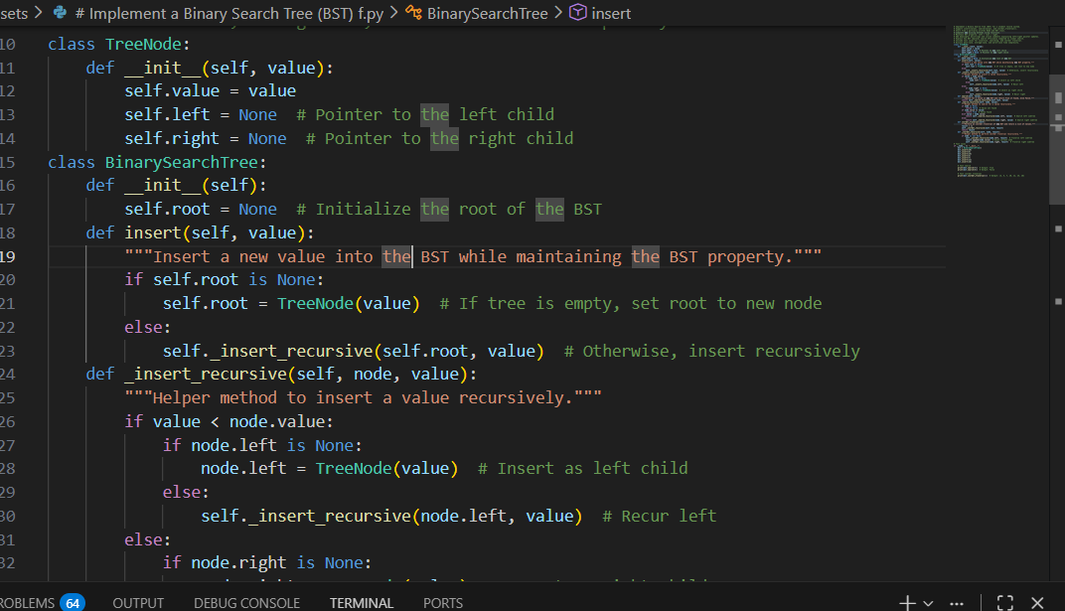
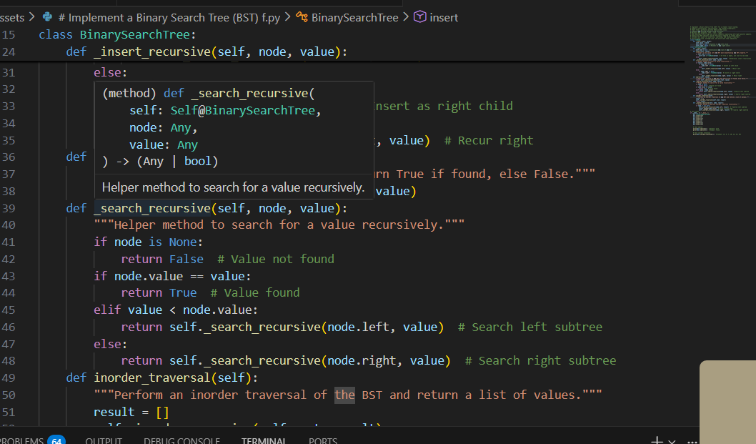
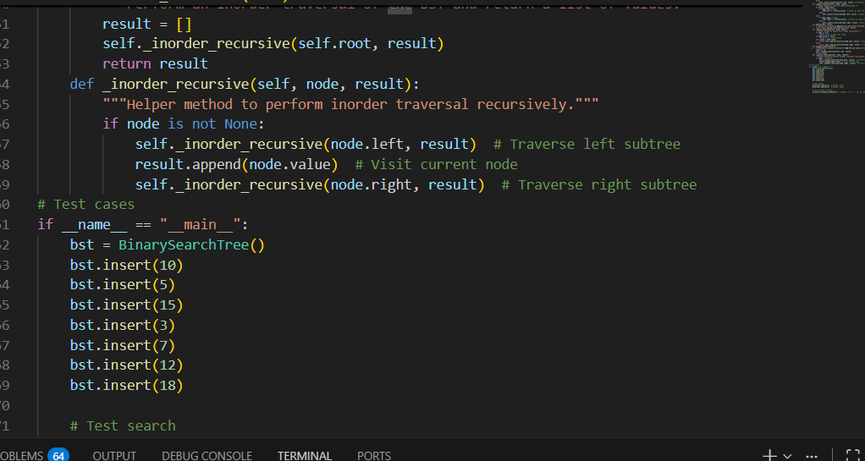
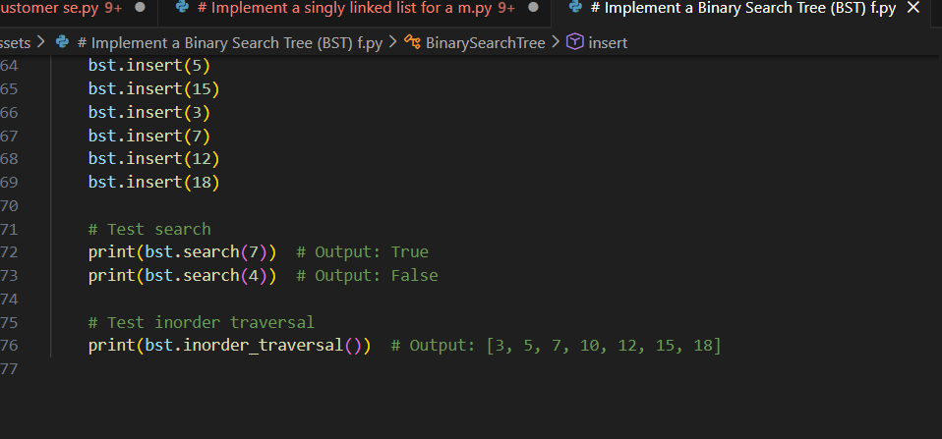
Output:
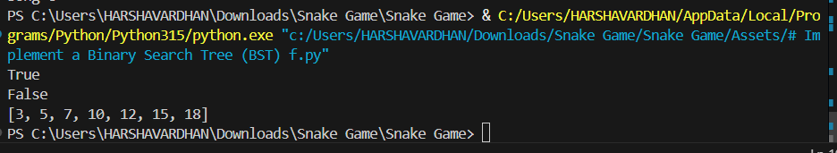
Explanation:
The code defines a Binary Search Tree (BST) data structure for managing student records. The TreeNode class represents each node in the tree, containing a value and pointers to the left and right children. The BinarySearchTree class provides methods for inserting values, searching for values, and performing an inorder traversal. The insert method adds new values while maintaining the BST property, ensuring that left children are less than the parent node and right children are greater. The search method checks for the presence of a value in the tree, and the inorder_traversal method returns a sorted list of values in the tree. The test cases demonstrate the functionality of the BST by inserting values, searching for existing and non-existing values, and performing an inorder traversal to display the sorted order of the values. The BST improves search efficiency compared to linear search by allowing it to skip large portions of the tree based on comparisons, resulting in an average-case time complexity of O(log n) for balanced trees, while linear search has a time complexity of O(n). However, in the worst case (e.g., when the tree is skewed), the time complexity can degrade to O(n).
Task 5: Graph Traversal for Social Network Connections
Scenario
You are modeling a social network, where users are connected to friends, and
you want to explore connections.
Prompt Used:
# Implement a graph to model social network connections using an adjacency list.
# Each user is a node, and friendships are edges.
# Implement graph traversal algorithms:
# - Breadth-First Search (BFS) to find nearby connections
# - Depth-First Search (DFS) to explore deep connection paths
# Add inline comments explaining each step of BFS and DFS traversal.
# Explain how queues are used in BFS and stacks/recursion are used in DFS.
# Implement DFS using:
# - Recursive approach
# - Iterative approach (using an explicit stack)
# Compare recursive vs iterative DFS in terms of memory and use cases.
# Explain practical real-world use cases of BFS vs DFS in social networks.
# Include sample test cases demonstrating:
# - BFS traversal from a given user
# - DFS traversal from a given user
# Keep the code clean, readable, and beginner-friendly.
AI-Generated Code
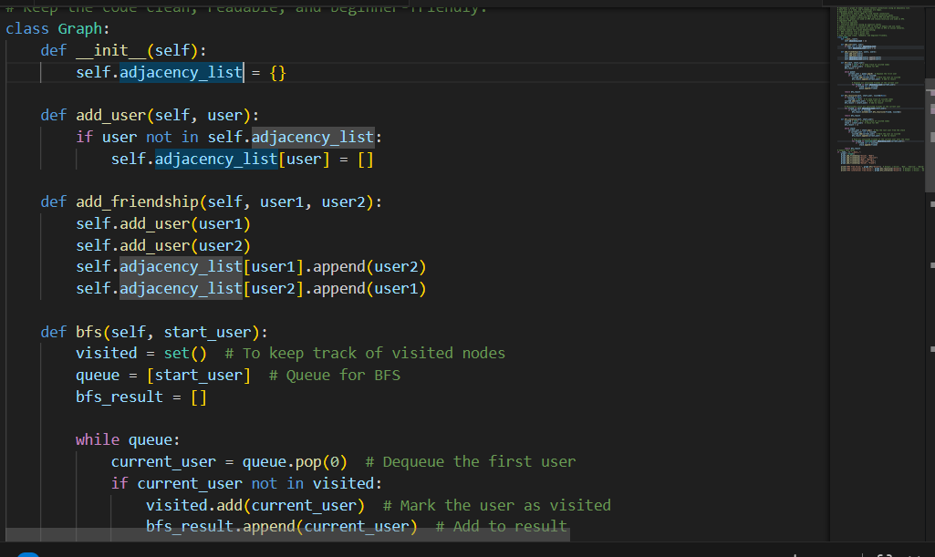
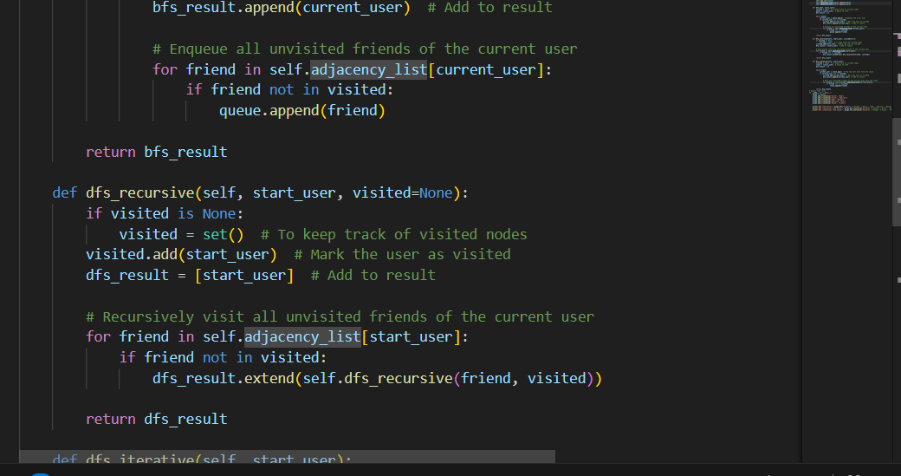
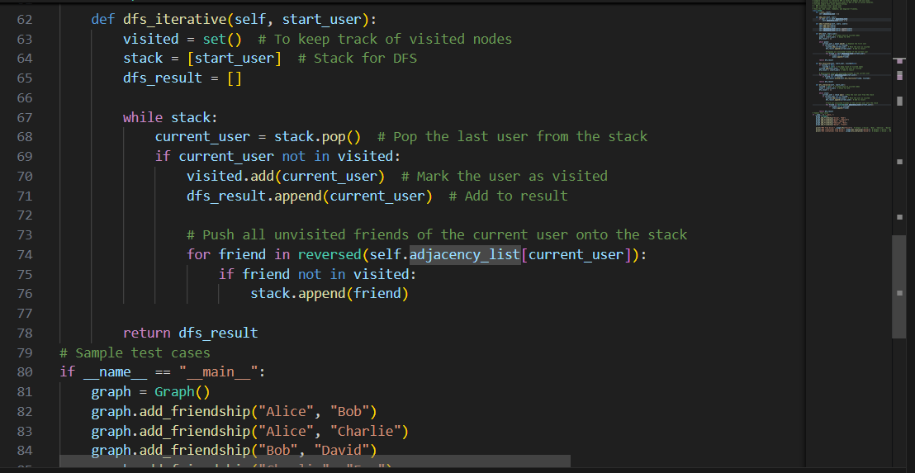
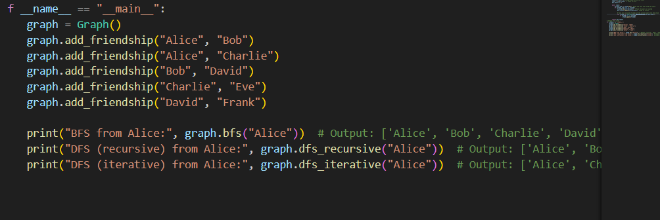
OUTPUT:
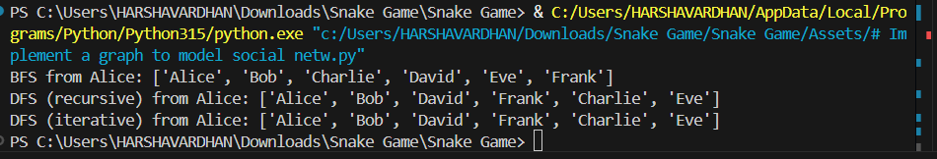
Explanation:
The code defines a Graph class to model social network connections using an adjacency list. Each user is represented as a node, and friendships are represented as edges between nodes. The Graph class provides methods to add users, add friendships, and perform breadth-first search (BFS) and depth-first search (DFS) traversals.

